Major Accident/Incident Report Form

This form must be completed immediately after any accident or significant incident

Date of Incident Time

Location (room, building, address)

Name of party involved Age

Home address and telephone number

About the accident/incident
Who was responsible for the group at that time?
Name Role

Home address and telephone number

Who witnessed the accident/incident? (please list all witnesses, use additional sheets if required)

 | Witness 1 | Witness 2 | Witness 3
Name

Age (if under 18)

Home address

Telephone number
Description of Accident/Incident in as much detail as possible (use addition sheets if required)

Immediate Action Taken

Injuries received

Treatment Given

By whom? Signature

Was a doctor seen? Yes/No (Delete as required)
Doctor’s name, address and telephone number

Was a hospital visit required? Yes/No (Delete as required)
Name and address of hospital

Details of advice and treatment given by medical professional (use additional sheet and/ or injury record sheet if necessary)

Have those with parental responsibility for the child been informed Yes/No

If so, by whom? Signature

Who else do you need to inform? (Minister, Provincial youth and children’s officer, church committee, insurance company as required)

Have they been informed? Yes/No

If so, by whom? Signature

To be completed by the leader in charge
Leader in charge of group at time of accident/incident

Name Signed Date

Review risk assessment Yes/No

Risk reduction action required

Implemented by Signed

This form must be stored in a safe secure place following the retention of documents guidance. In cases of legal action it may be required as evidence so it is important that it is completed as fully as possible.

There is the personal information of several people on this form. There is an appropriate reason to keep this information, but it should be dealt with in a confidential way following GDPR guidance. It should only be shared with caution to those with the right to see it.

Injury record sheet

- Bleeding
- Burn
- Bruise
- Dislocation
- Fracture
- Embedded object
- Pain
- Swelling

Please mark on the figure the site and
type of injuries
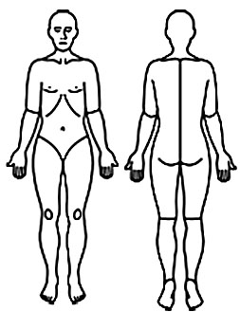
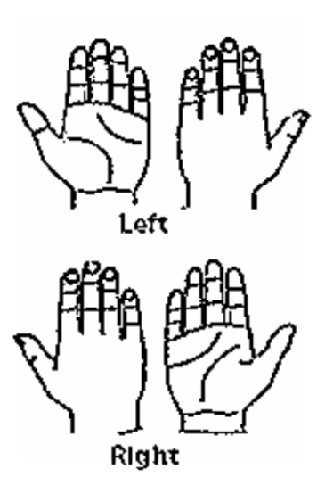
Clinical observations
Pulse
Breathing
Pain
Temperature

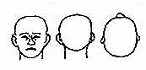

Notes

Recorded by Signature Date/time

